
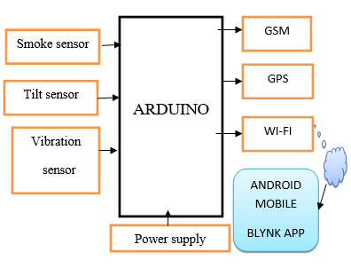
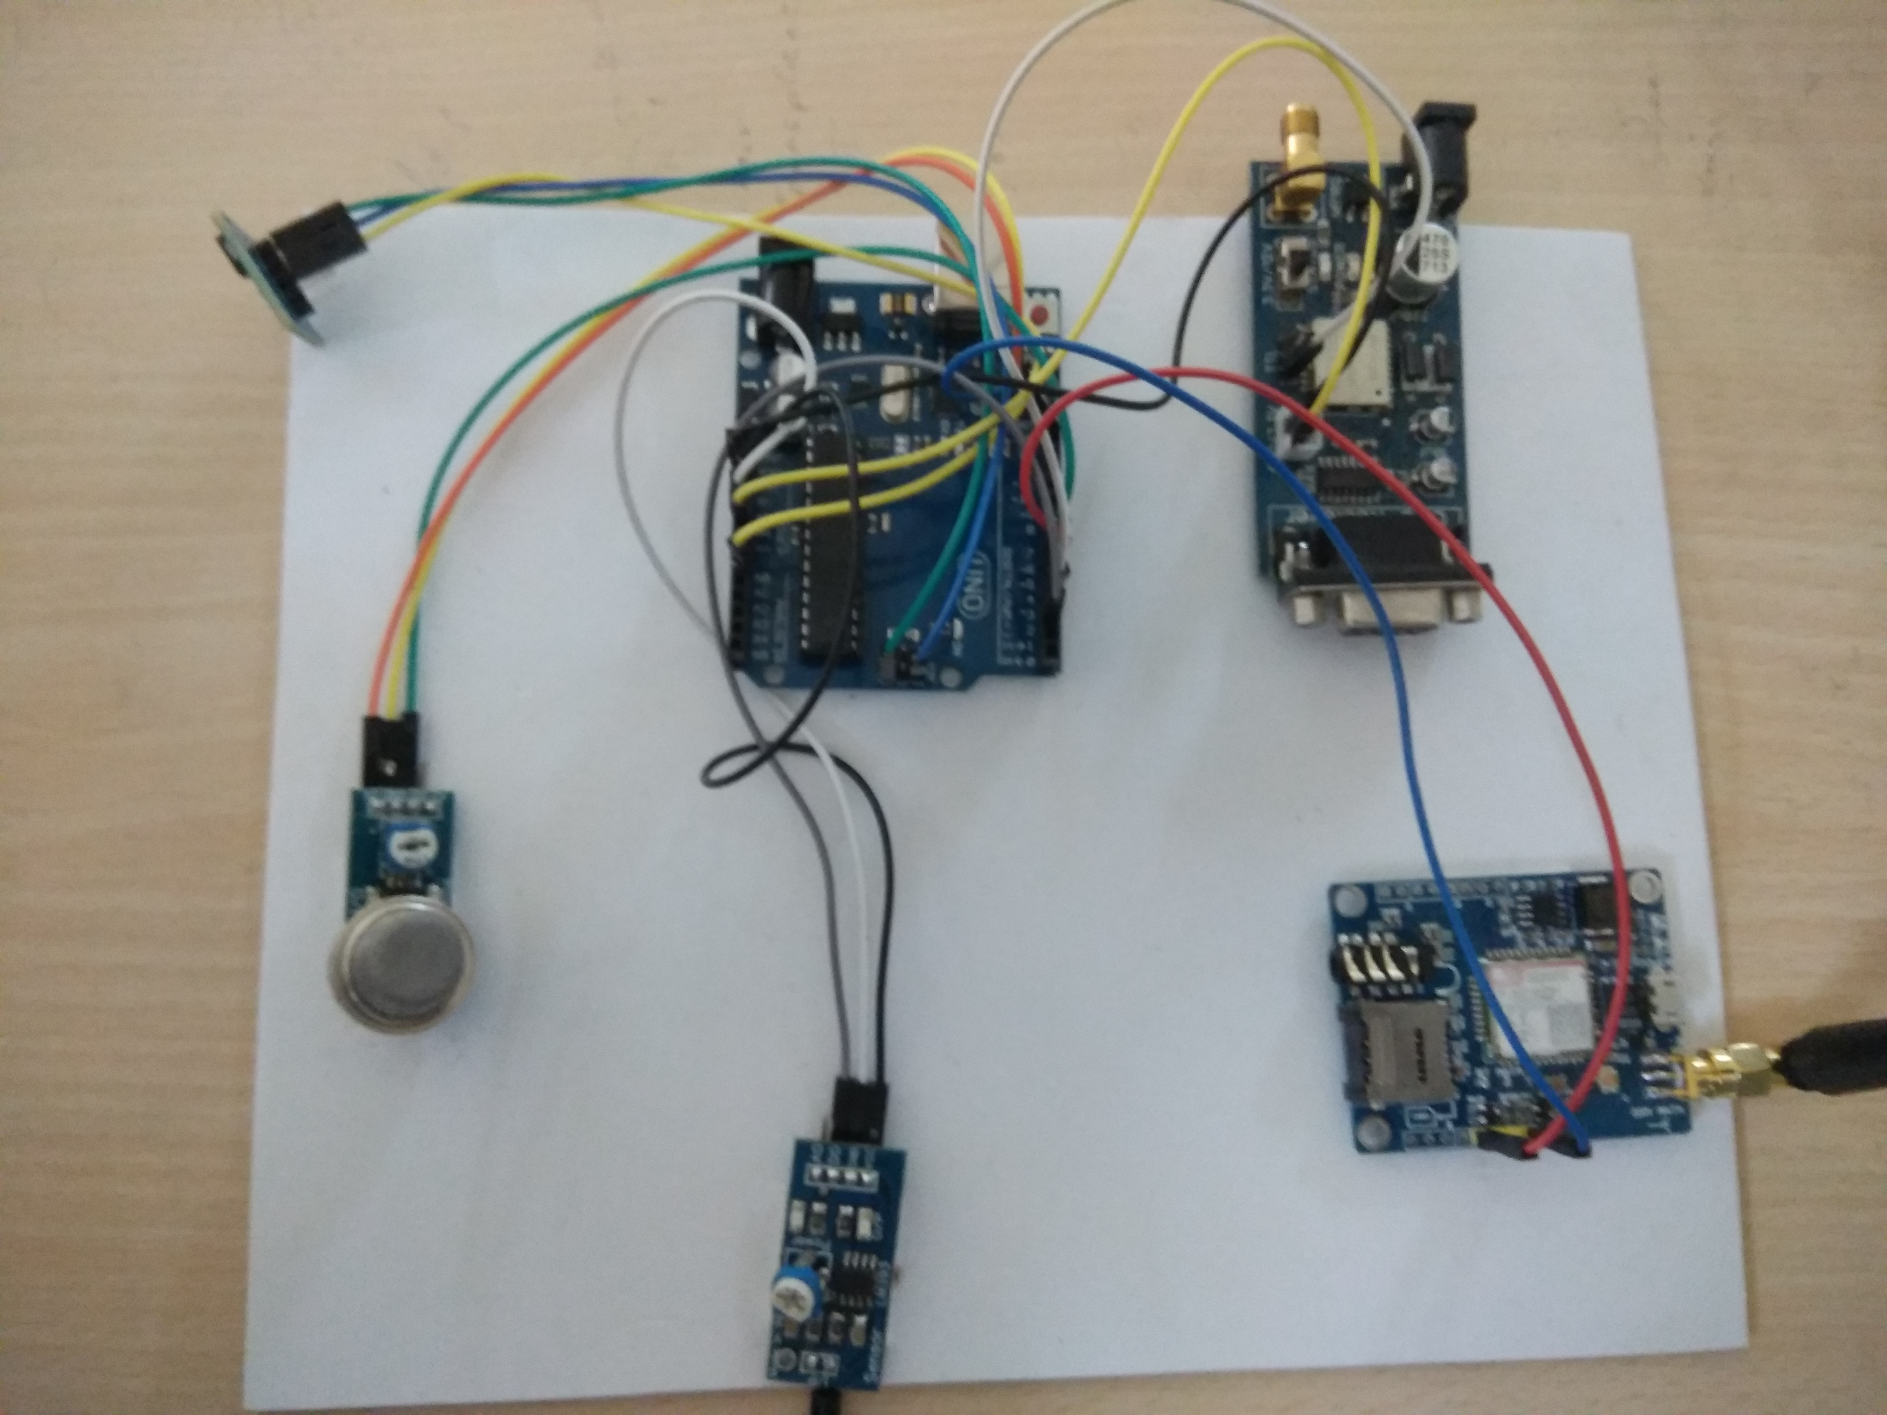
School of Computer Science & Engineering
REAL TIME INFORMATION DISSEMINATION USING GPS ON VEHICLE ACCIDENT DETECTION

WHY This IOT Model?
This project aims to detecting the accident and provides the safety features and reports the location of accident.
Because IOT allows automation of daily tasks which leads to better monitoring of devices.
It is Efficient saves time & money.
IOT encourages communication among devices hence total Transparency is available with lesser inefficiency and Greater Quality.

APPLICATIONS
Stolen Vehicle Recovery
Fleet Management
Transit Tracking
Live Insights
Process Optimization
New Business Model
CHALLENGES
Privacy and Security
Safety
Complexity
Compatibility
Lesser Employment of Menial Staff
Less Reaction Time
GUIDE: Dr. PRABHAKAR.M

Name: M M Harish Kumar (R14CS063)
Manikandan.R (R14CS099)
K. Nirosh(R14CS073)
Vijay Kumar Reddy (R14CS091)

School of C & IT,
REVA University, Bangalore

